7/29/2021

**Name:- Pawar Ajay Gulab Branch:- Computer Science & Engineering Sem:-2 Pen No.:- 200490131023 Subject:- Programming For Problem Solving (3110003)**

**[Practical Book]**

**Practical No.:-1**

1. **Write a program to print “Hello World” on output screen.**

**Code:-**

**#include <stdio.h>**

**int main()**

**{**

**printf("Hello World");**

**return 0;**

**}**

**Output:-**

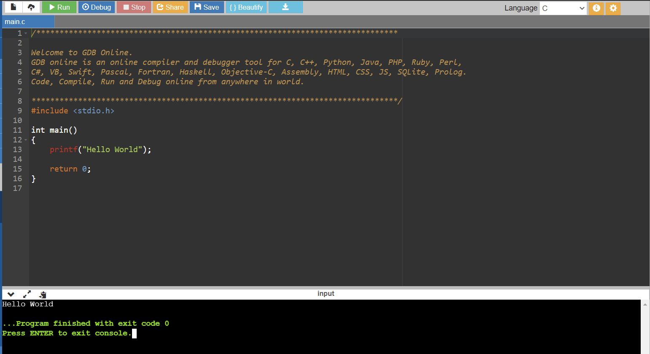

1. **Write a program to compute Fahrenheit from centigrade [f=(1.8*C)+32].**

**Code:-**

**#include <stdio.h>**

**int main()**

**{**

**float fahr,cent;**

**printf("Give me the value of temperature in Centigrade\n");**

**scanf("%f",&cent);**

**fahr=(1.8*cent)+32;**

**printf("Centigrade temperature=%f\n",cent);**

**printf("Fahrenheit temperature=%f\n",fahr);**

**return 0;**

**}**

**Output:-**

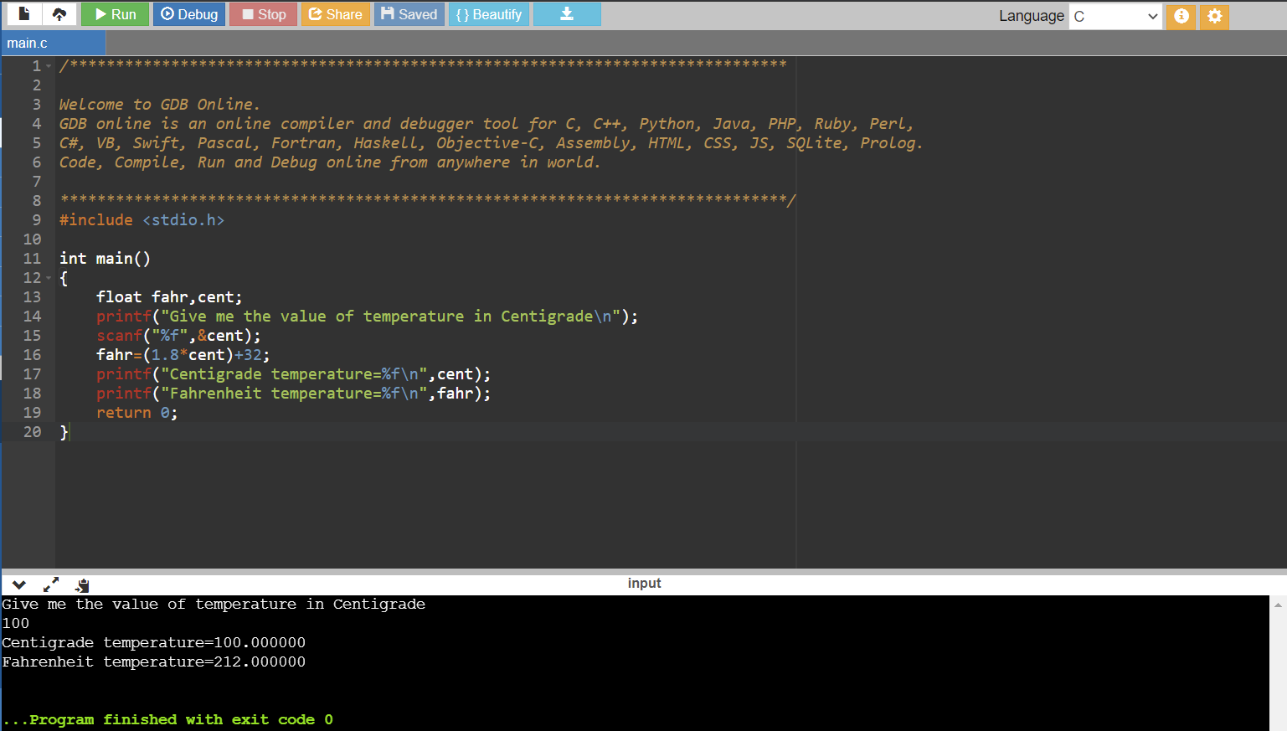

1. **Write a program to interchange two numbers.**

**Code:-**

**#include <stdio.h>**

**int main()**

**{**

**int x,y,temp;**

**x=5;**

**y=3;**

**printf("Before exchange x=%d and y=%d\n",x,y);**

**temp=x;**

**x=y;**

**y=temp;**

**printf("After exchange x=%d and y=%d\n",x,y);**

**return 0;**

**}**

**Output:-**

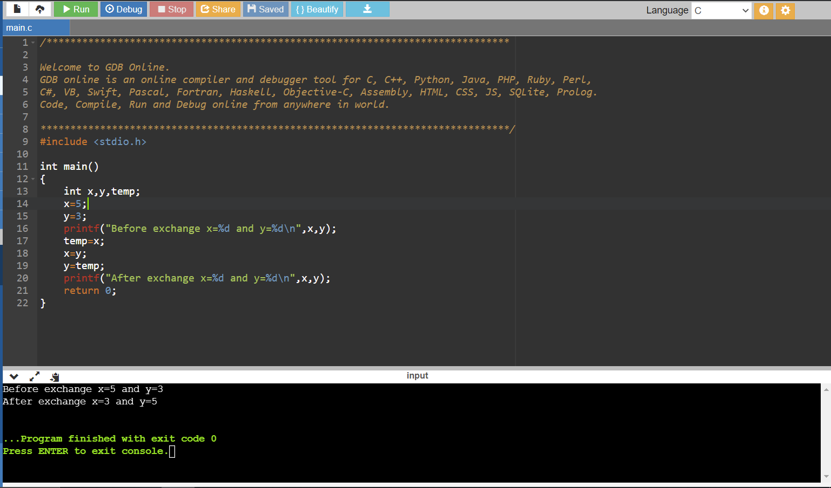

**Practical No.:-2**

1. **Write a program to find area of triangle. (a=h*b*0.5)**

**a=area**

**h=height**

**b=base**

**Code:-**

**#include <stdio.h>**

**int main()**

**{**

**float h,b,area;**

**printf("Enter the value of Area of traingle\n");**

**scanf("%f %f", &h,&b);**

**/*compute a*/**

**area=h*b*0.5;**

**printf("Area of a triangle=%f\n",area);**

**return 0;**

**}**

**Output:-**

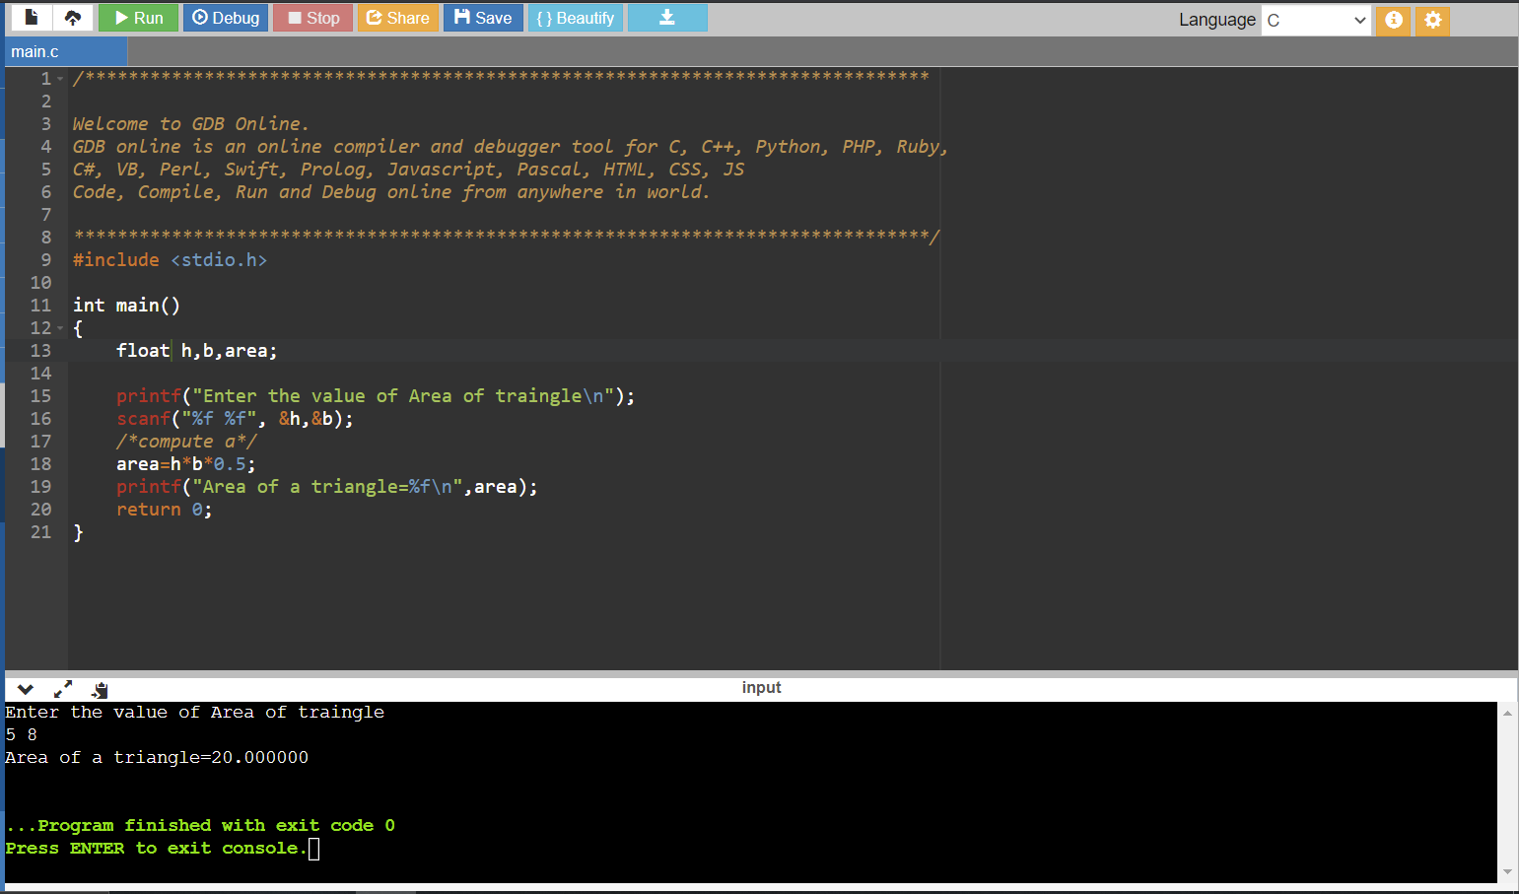

1. **Write a program to calculate simple interest. [i=p*r*n)/100]**

**i=Simple interest**

**p=Principal amount**

**r=Rate of interest**

**n=Number of years**

**Code:-**

**#include <stdio.h>**

**int main()**

**{**

**int p,n;**

**float r,i;**

**printf("Please give principal amount\n");**

**scanf("%d", &p);**

**printf("\nPlease give rate of interest and number of years\n");**

**scanf("%f %d",&r,&n);**

**i=(p*r*n)/100;**

**printf("\nInterest of amount Rs. %d at rate %f%% for %d years=%f\n",p,r,n,i);**

**return 0;**

**}**

**Output:-**

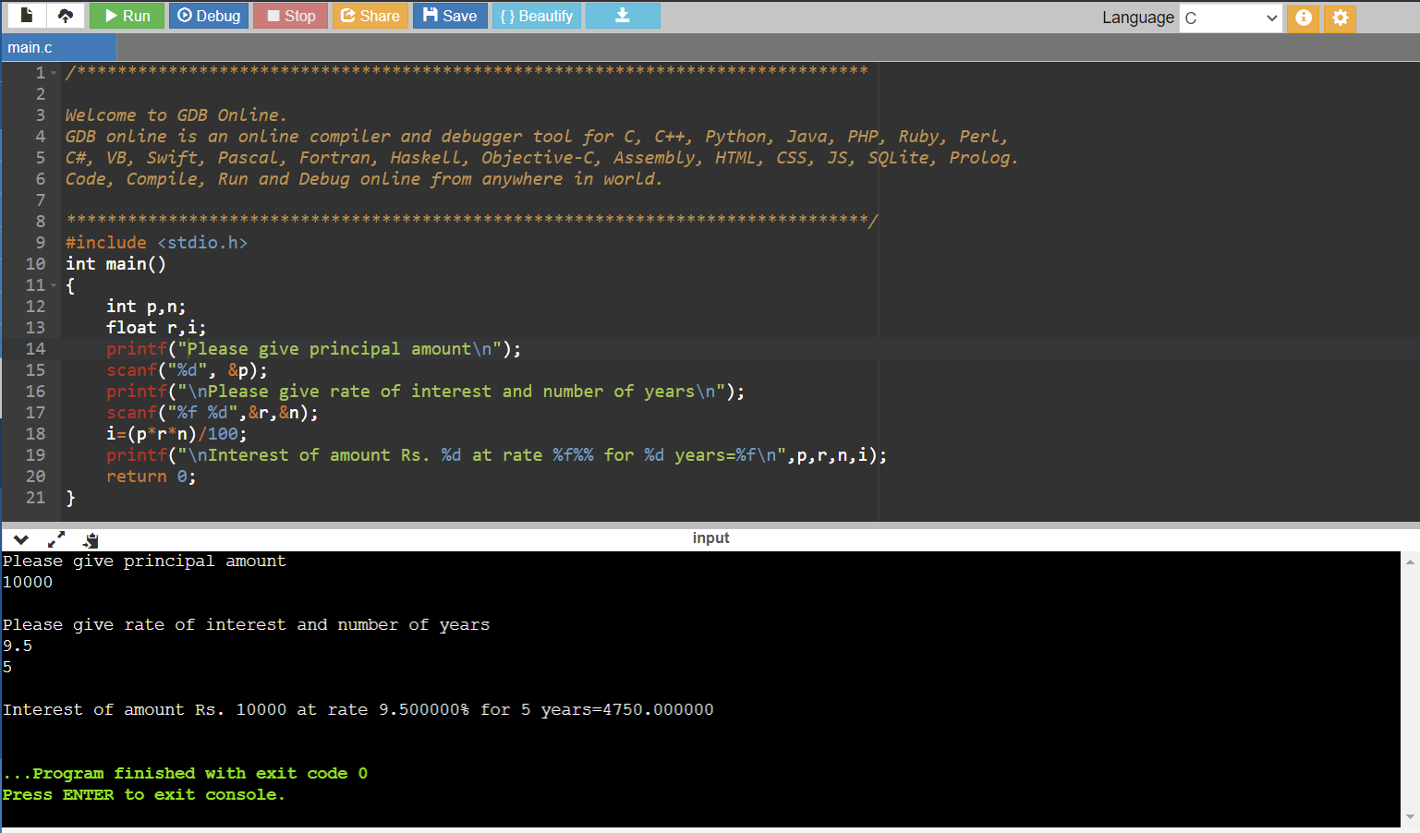

1. **Write a C program to find that the accepted number is Negative, or Positive or Zero.**

**Code:-**

**#include <stdio.h>**

**int main()**

**{**

**int no;**

**printf("Enter any number :");**

**scanf("%d",&no);**

**if(no==0)**

**{**

**printf("\nEntered Number is Zero");**

**}**

**else if(no>0)**

**{**

**printf("\nEntered Number is Positive");**

**}**

**else**

**{**

**printf("\nEntered Number is Negative");**

**}**

**return 0;**

**}**

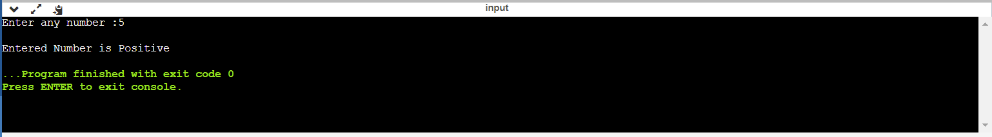 **Output:-**

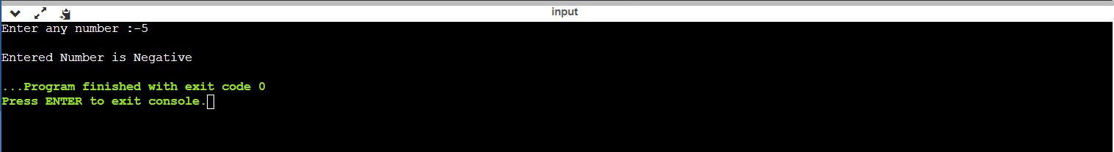

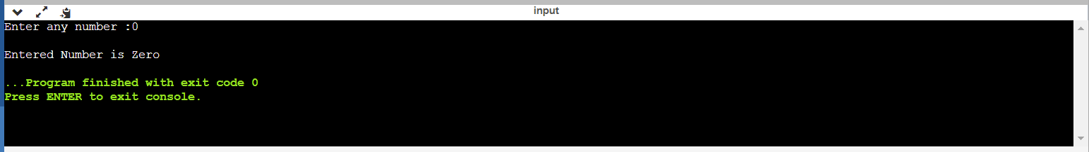

1. **Write a program to read marks of a student from keyboard whether the student is pass or fail. (using if else)**

**Code:-**

**#include<stdio.h>**

**int main()**

**{**

**int marks;**

**printf("Enter Marks from 0-70 :");**

**scanf("%d",&marks);**

**if(marks<23)**

**{**

**printf("\n Sorry ..! You are Fail");**

**}**

**else**

**{**

**printf("\nCongratulation ...! You are Pass");**

**}**

**return 0;**

**}**

**Output:-**

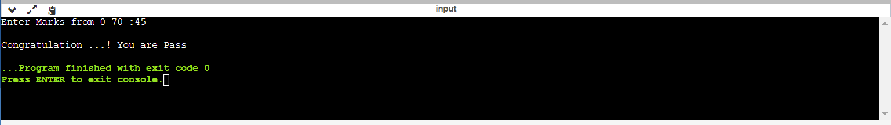

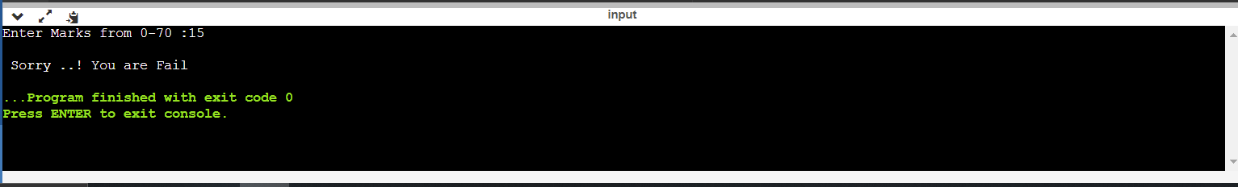

**Practical No.:-3**

1. **Write a program to read three numbers from keyboard and find out maximum out these three. (nested if else)**

**Code:-**

**#include <stdio.h>**

**int main()**

**{**

**int num1,num2,num3;**

**printf("enter three numbers: ");**

**scanf("%d%d%d",&num1,&num2,&num3);**

**//checking num1>num2,if true-->check num1>num3,if true-->num1 is largest**

**// false-->num2 is grater than num1 so check,if num2>num3,if true-->num2 is largest**

**if(num1>num2)**

**{**

**if(num1>num3)**

**{**

**printf("%d is largest number",num1);**

**}**

**else**

**{**

**printf("%d is largest number",num3);**

**}**

**}**

**if(num3>num2)**

**{**

**if(num1>num3)**

**{**

**printf("%d is largest number",num2);**

**}**

**else**

**{**

**printf("%d is largest number",num3);**

**}**

**}**

**return 0;**

**}**

**Output:-**

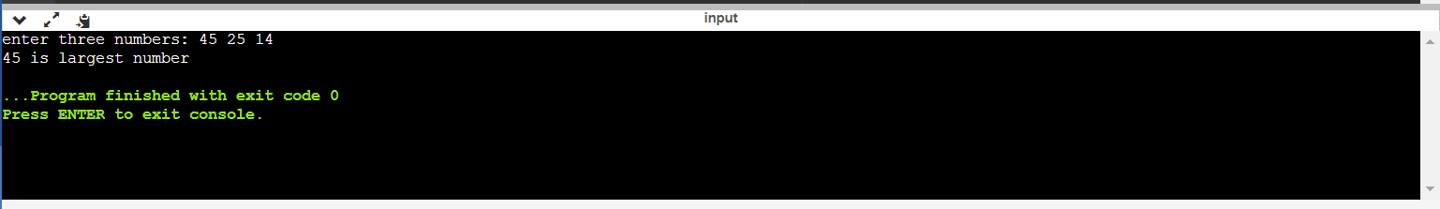

1. **Write a C program to check whether the entered character is capital, small letter, digit or any special character.**

**Code:-**

**#include <stdio.h>**

**double main()**

**{**

**char ch;**

**printf("Enter one character\n");**

**scanf("%c",&ch);**

**if((ch>='A') && (ch<='Z'))**

**{**

**printf("The character %c is Upper Case\n",ch);**

**}**

**else if((ch>='a') && (ch<='z'))**

**{**

**printf("The character %c is Lower Case\n",ch);**

**}**

**else if((ch>='0') && (ch<='9'))**

**{**

**printf("The character %c is Digit\n",ch);**

**}**

**else**

**{**

**printf("The character %c is Special Character\n",ch);**

**}**

**}**

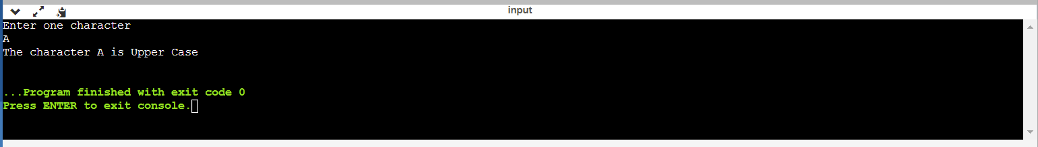**Output:-**

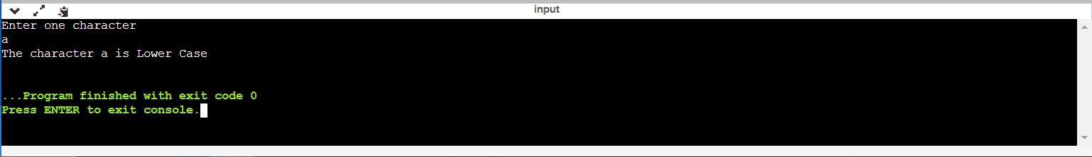

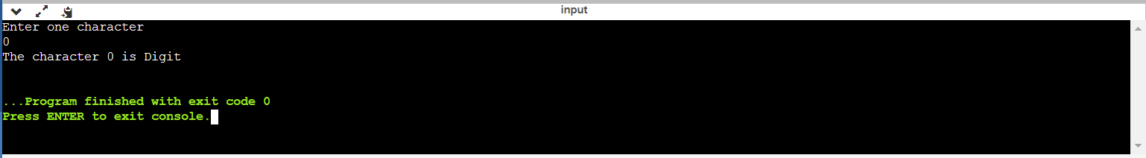

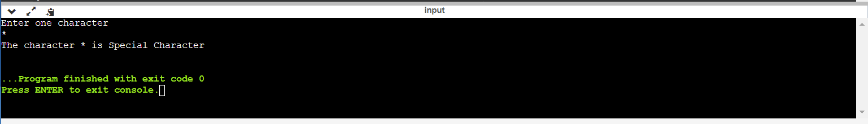

1. **Write a program to read marks from keyboard and your program should display equivalent grade according to following table. (if else ladder)**

**Marks Grade**

**100 – 80 Distinction**

**79 – 60 First Class**

**59 – 40 Second Class**

**<40 Fail**

**Code:-**

**#include<stdio.h>**

**int main()**

**{**

**int marks;**

**printf("Enter Marks between 0-100 :");**

**scanf("%d",&marks);**

**if(marks>100 || marks <0)**

**{**

**printf("\n Your Input is out of Range");**

**}**

**else if(marks>=80)**

**{**

**printf("\n You got Distinction");**

**}**

**else if(marks>=60)**

**{**

**printf("\n You got First Class");**

**}**

**else if(marks>=40)**

**{**

**printf("\n You got Second Class");**

**}**

**else**

**{**

**printf("\n You got Fail");**

**}**

**return 0;**

**}**

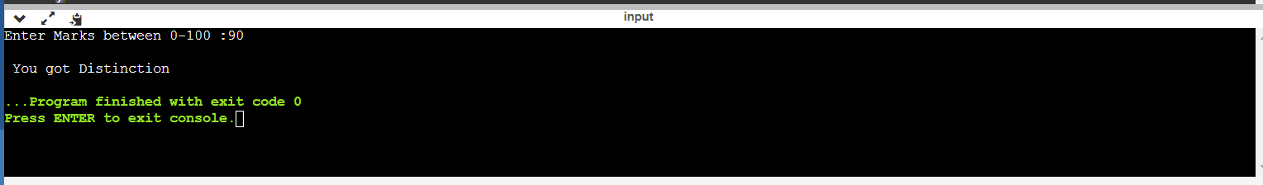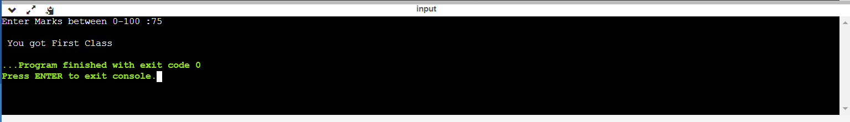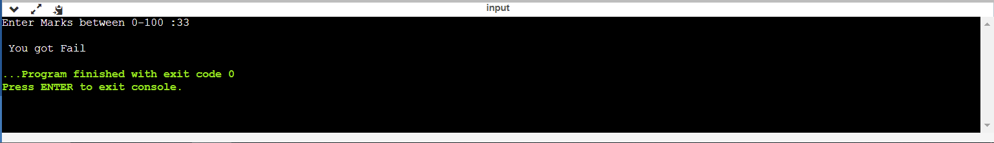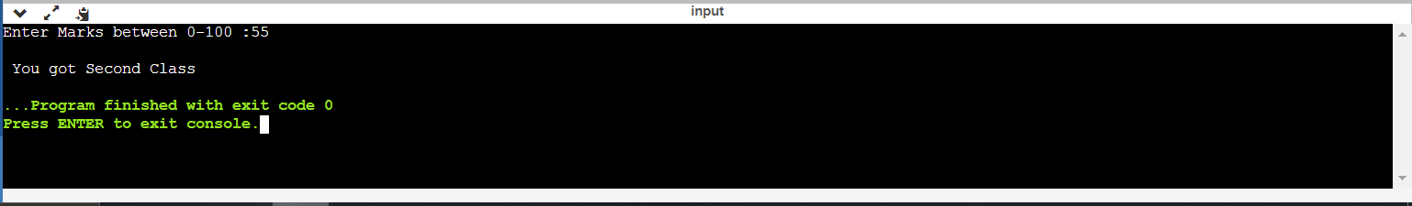**Output:-**

**Practical No.:-4**

1. **Write a C program to find out the Maximum and minimum number from given 10 numbers.**

**Code:-**

**#include <stdio.h>**

**int main()**

**{**

**int a[10],i,min,max;**

**for(i=0;i<10;i++)**

**{**

**printf("\n Enter Interger Value [%d] : ",i+1);**

**scanf("%d",&a[i]);**

**if(i==0)**

**{**

**min=max=a[i];**

**}**

**else**

**{**

**if(min>a[i])**

**{**

**min=a[i];**

**}**

**if(max<a[i])**

**{**

**max=a[i];**

**}**

**}**

**}**

**printf("\n Minimum Number: %d",min);**

**printf("\n Maximum Number: %d",max);**

**return 0;**

**}**

**Output:-**

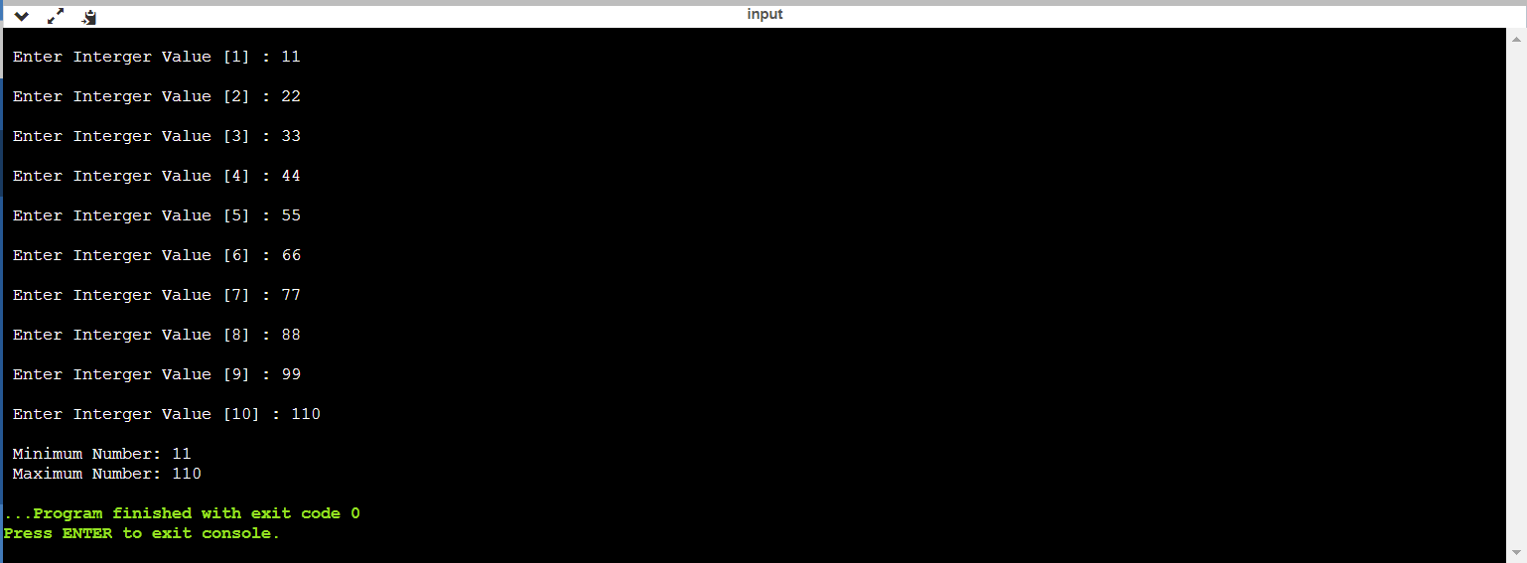

1. **Write a C program to find factorial of a given number.**

**Code:-**

**#include <stdio.h>**

**int main()**

**{**

**int i,n;**

**long int fact;**

**printf("Give positive number for which factorial is to be found\n");**

**scanf("%d",&n);**

**if(n<0)**

**{**

**printf("Factorial of negative number not defined\n");**

**}**

**else**

**{**

**fact=1;**

**for(i=1;i<=n;i++)**

**{**

**fact=fact*i;**

**}**

**printf("Factorial of %d is=%ld\n",n,fact);**

**}**

**return 0;**

**}**

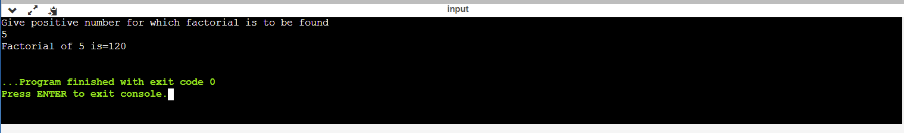**Output:-**

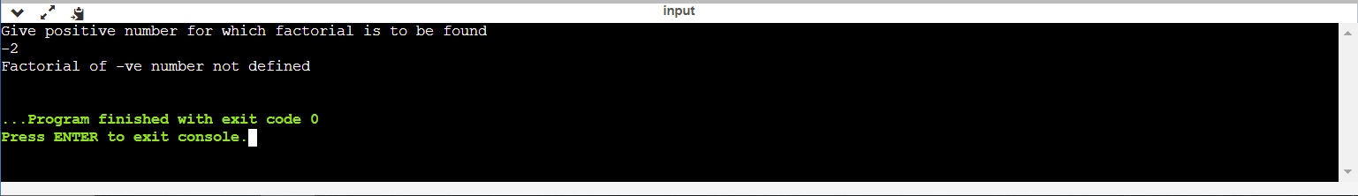

1. **Write a program to reverse a number.**

**Code:-**

**#include <stdio.h>**

**int main()**

**{**

**int num,i;**

**printf("Give Integer Number\n");**

**scanf("%d",&num);**

**printf("Reverse of %d is=",num);**

**while(num!=0)**

**{**

**i=num%10;**

**printf("%d",i);**

**num=num/10;**

**}**

**return 0;**

**}**

**Output:-**

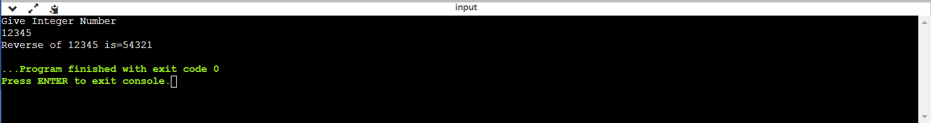

1. **Write a program to generate first n number of Fibonacci series.**

**Code:-**

**#include <stdio.h>**

**int main()**

**{**

**int num1,num2,num3,n;**

**int count;**

**num1=0;**

**num2=1;**

**printf("How many Fibonacci numbers you to print?\n");**

**scanf("%d",&n);**

**if(n>2)**

**{**

**printf("The Fibonacci numbers are\n");**

**printf("%5d%5d",num1,num2);**

**count=2;**

**while(count<n)**

**{**

**num3=num1+num2;**

**printf("%5d",num3);**

**num1=num2;**

**num2=num3;**

**count++;**

**}**

**}**

**else**

**{**

**printf("By definition first two numbers are 0 1\n");**

**}**

**return 0;**

**}**

**Output:-**

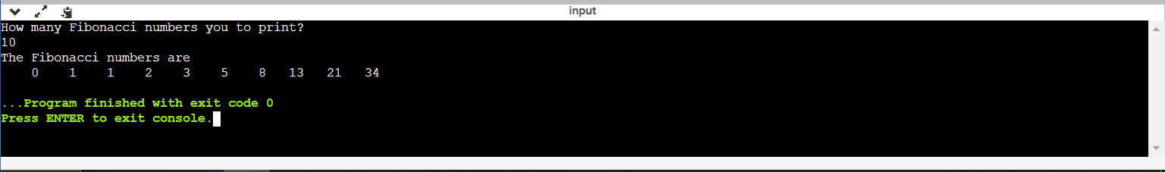

**Practical No.:-5**

1. **Write a program to check whether the given number is prime or not.**

**Code:-**

**#include <stdio.h>**

**int main()**

**{**

**int num,i,ctr=0;**

**printf("Input a number: ");**

**scanf("%d",&num);**

**for(i=2;i<=num/2;i++)**

**{**

**if(num % i==0)**

**{**

**ctr++;**

**break;**

**}**

**}**

**if(ctr==0 && num!= 1)**

**{**

**printf("%d is a prime number.\n",num);**

**}**

**else**

**{**

**printf("%d is not a prime number",num);**

**}**

**return 0;**

**}**

**Output:-**

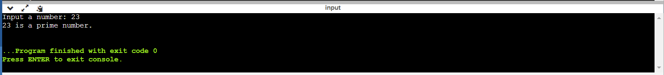

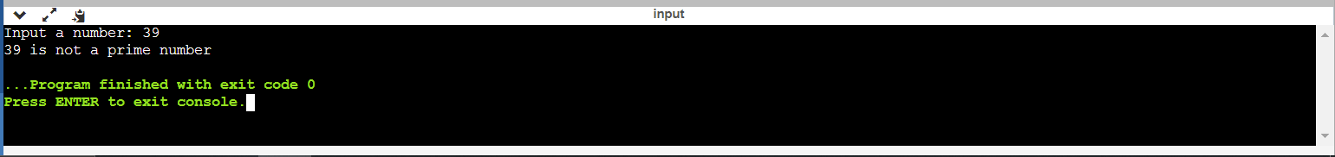

1. **Write a program to evaluate the series 1^2+2^2+3^2+. . . .+n^2.**

**Code:-**

**#include <stdio.h>**

**int main()**

**{**

**int number,i;**

**int sum=0;**

**printf("Enter maximum values of series number:");**

**scanf("%d", &number);**

**sum=(number*(number+ 1)*(2*number+ 1));**

**printf("Sum of the above given series:");**

**for (i=1;i<=number;i++)**

**{**

**if(i!=number)**

**{**

**printf("%d^2+",i);**

**}**

**else**

**{**

**printf("%d^2=%d",i,sum);**

**}**

**}**

**return 0;**

**}**

**Output:-**

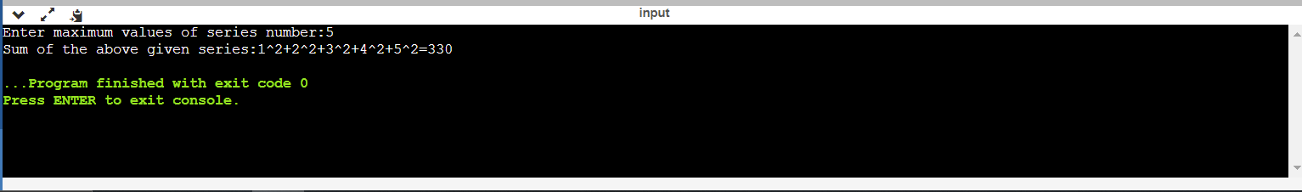

1. **Write a C program to find 1+1/2+1/3+1/4+. . . .+1/n.**

**Code:-**

**#include<stdio.h>**

**int main()**

**{**

**int num,i,sum=0;**

**printf("Input any number: ");**

**scanf("%d",&num);**

**printf("1 + ");**

**for(i=2;i<=num-1;i++)**

**{**

**printf(" 1/%d +",i);**

**for(i=2;i<=num;i++)**

**{**

**sum = sum + i;**

**printf(" 1/%d",num);**

**}**

**printf("\nSum = 1/%d",sum+1/num);**

**}**

**return 0;**

**}**

**Output:-**

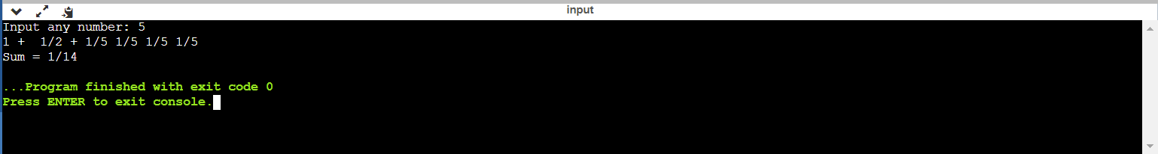

1. **Write a C program to find 1+1/2!+1/3!+1/4!+. . . .+1/n!**

**Code:-**

**#include<stdio.h>**

**int main()**

**{**

**int n,i,j,fact=1;**

**float sum=0;**

**printf("Enter Value of n: ");**

**scanf("%d",&n);**

**for(i=1;i<=n;i++)**

**{**

**fact=1;**

**for(j=i;j>0;j--)**

**{**

**fact=fact * j;**

**}**

**sum=sum+(1.0/fact);**

**}**

**printf("\nSum of Series = %f",sum);**

**return 0;**

**}**

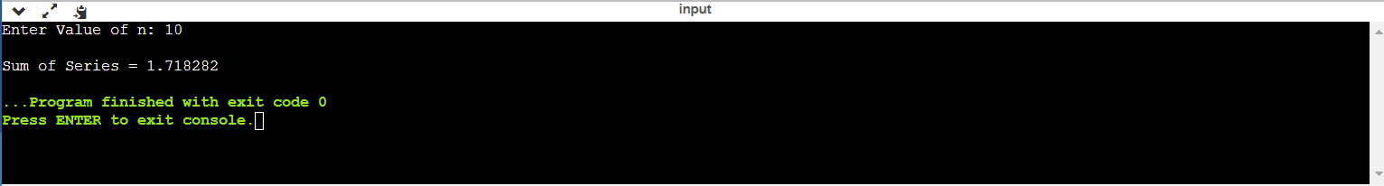**Output:-**

**Practical No.:-6**

1. **Write a program to print following patterns:**

**i) \***

**\* \***

**\* * \***

**\* * * \***

**Code:-**

**#include <stdio.h>**

**int main()**

**{**

**int n,row,col;**

**printf("in how many rows do you want print * ??");**

**scanf("%d",&n);**

**for(row=1;row<=n;row++) //new line ma**

**{**

**for(col=1;col<=row;col++) //ek j line ma badha * print karva mate**

**{**

**printf(" * "); //\*\*\*\*\*\*\*\*\***

**}**

**printf("\n");**

**}**

**return 0;**

**}**

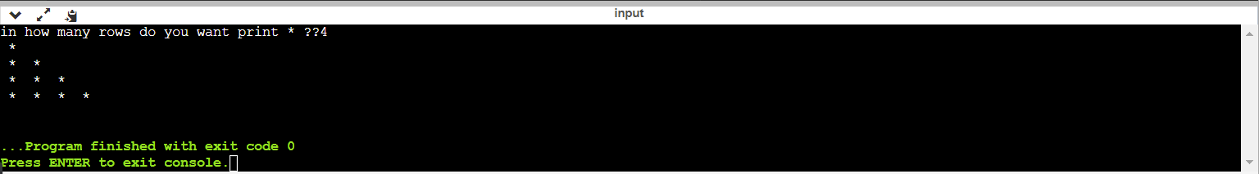**Output:-**

**ii) \***

**\* \***

**\* * \***

**\* * * \***

**Code:-**

**#include <stdio.h>**

**int main()**

**{**

**int i, j, rows, x = 0;**

**printf (" Enter a number to define the rows: \n");**

**scanf ("%d", &rows);**

**for ( i =1; i <= rows; i++)**

**{**

**for ( j = 1; j <= rows - i; j++)**

**{**

**printf (" ");**

**}**

**for ( x = 1; x <= ( 2 * i - 1); x++)**

**{**

**printf ("* ");**

**}**

**printf ("\n");**

**}**

**return 0;**

**}**

**Output:-**

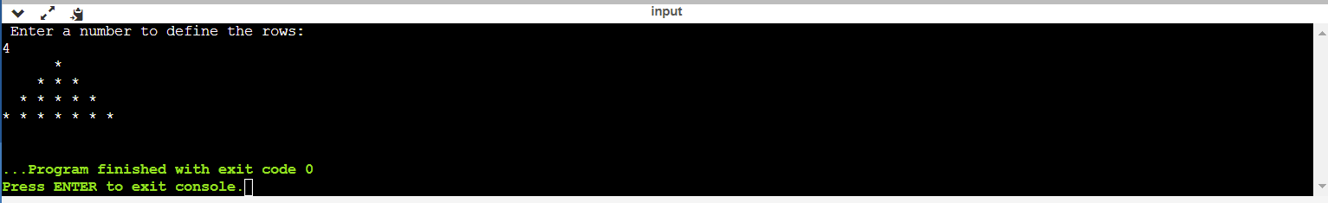

1. **Write a program to print following patterns :**
2. **1**

**12**

**123**

**1234**

**12345**

**Code:-**

**#include<stdio.h>**

**int main()**

**{**

**int i,j,row;**

**printf("How many rows\n");**

**scanf("%d",&row);**

**for(i=1;i<=row;i++)**

**{**

**for(j=1;j<=i;j++)**

**{**

**printf("%d",j);**

**}**

**printf("\n");**

**}**

**return 0;**

**}**

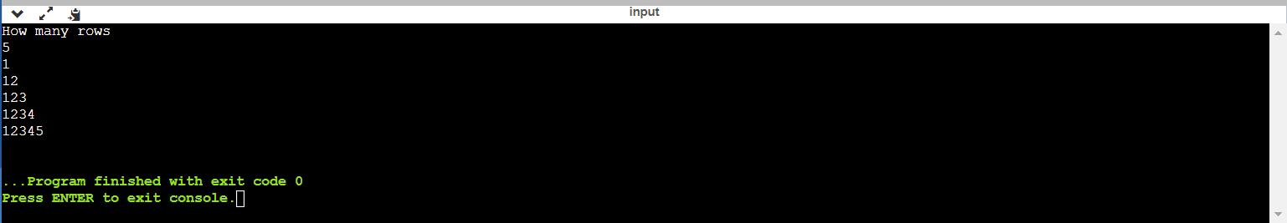**Output:-**

1. **55555**

**4444**

**333**

**22**

**1**

**Code:-**

**#include <stdio.h>**

**int main()**

**{**

**int row,col,n;**

**printf("enter numbers of lines: ");**

**scanf("%d",&n);**

**for (row=n;row>=1;row--)**

**{**

**for (col=1;col<=row;col++)**

**{**

**printf(" %d ",row);**

**}**

**printf("\n");**

**}**

**return 0;**

**}**

**Output:-**

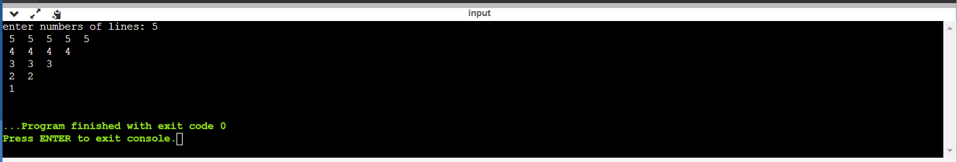

**Practical No.:-7**

1. **Write a program to find out which number is even or odd from list of 10 numbers using array.**

**Code:-**

**#include <stdio.h>**

**int main()**

**{**

**int array[100], i, num;**

**printf("Enter the size of an array \n");**

**scanf("%d", &num);**

**printf("Enter the elements of the array \n");**

**for (i = 0; i < num; i++)**

**{**

**scanf("%d", &array[i]);**

**}**

**printf("Even numbers in the array are - ");**

**for (i = 0; i < num; i++)**

**{**

**if (array[i] % 2 == 0)**

**{**

**printf("%d \t", array[i]);**

**}**

**}**

**printf("\nOdd numbers in the array are - ");**

**for (i = 0; i < num; i++)**

**{**

**if (array[i] % 2 != 0)**

**{**

**printf("%d \t", array[i]);**

**}**

**}**

**return 0;**

**}**

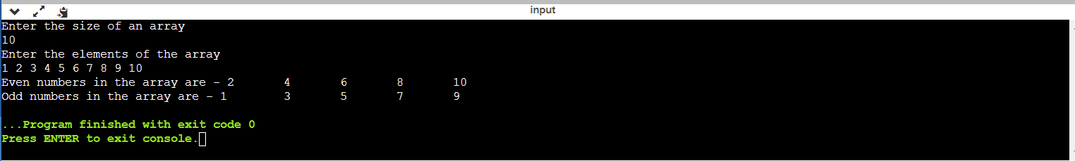**Output:-**

1. **Write a program to find maximum element from 1-Dimensional array.**

**Code:-**

**#include <stdio.h>**

**int main()**

**{**

**int a[10],i,n,max;**

**printf("Enter How many numbers you want to enter [Max 10] : ");**

**scanf("%d",&n);**

**for(i=0;i<n;i++)**

**{**

**printf("Enter Value in Array at Position [%d] :",i+1);**

**scanf("%d",&a[i]);**

**if(i==0)**

**{**

**max=a[i];**

**}**

**else**

**{**

**if(max<a[i])**

**{**

**max=a[i];**

**}**

**}**

**}**

**printf("\n Maximum Value in Array = %d",max);**

**return 0;**

**}**

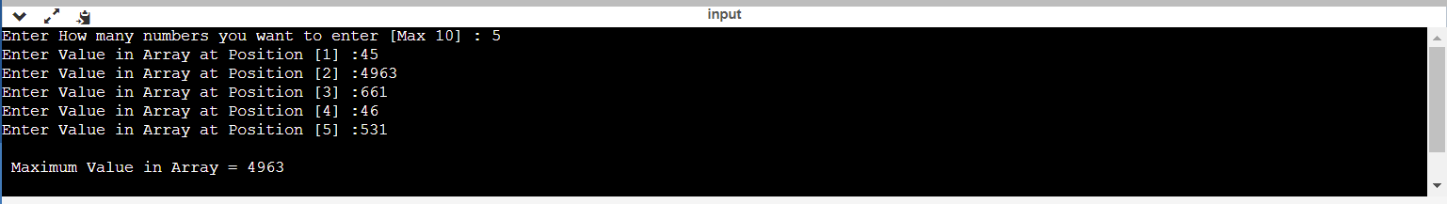**Output:-**

1. **Write a program to sort given array in ascending order (Use any one---Insertion sort, Bubble sort,Selection sort,Mergesort,Quicksort,Heapsort).**

**Code:-**

**#include <stdio.h>**

**int main()**

**{**

**int a[10],i,j,n,min,temp;**

**printf("Enter How many numbers you want to enter: ");**

**scanf("%d",&n);**

**for (i = 0; i < n; i++)**

**{**

**printf("Enter Value at Position [%d] :",i+1);**

**scanf("%d",&a[i]);**

**}**

**for (i = 0; i < n-1; i++)**

**{**

**// Find the minimum element in unsorted array**

**min = a[i];**

**for (j = i+1; j < n; j++)**

**{**

**if (a[j] < a[i])**

**{**

**min = j;**

**// Swap the found minimum element with the first element**

**temp=a[i];**

**a[i]=a[j];**

**a[j]=temp;**

**}**

**}**

**printf(" %d ->",a[i]);**

**}**

**printf(" %d ->",a[i]);**

**return 0;**

**}**

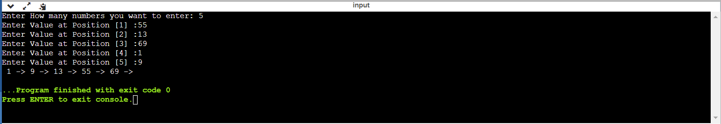**Output:-**

**Practical No.:-8**

1. **Write a program to reverse string.**

**Code:-**

**#include <stdio.h>**

**#include <string.h>**

**int main()**

**{**

**char string[20],temp;**

**int i,length;**

**printf("Enter String : ");**

**scanf("%s",string);**

**length=strlen(string)-1;**

**for(i=0;i<strlen(string)/2;i++)**

**{**

**temp=string[i];**

**string[i]=string[length];**

**string[length--]=temp;**

**}**

**printf("\nReverse string :%s",string);**

**return 0;**

**}**

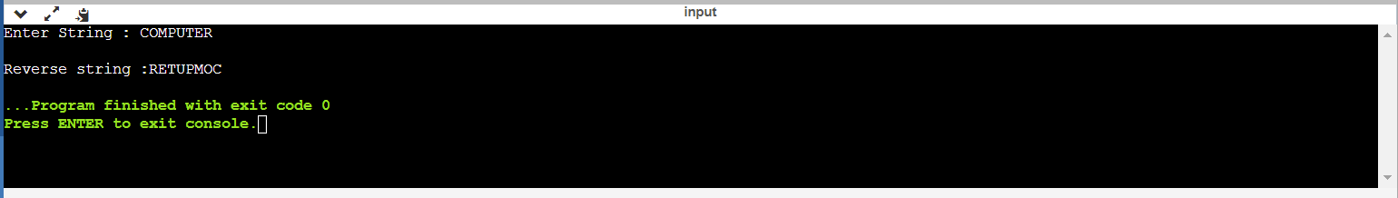**Output:-**

1. **Write a program to convert string into upper case.**

**Code:-**

**#include<stdio.h>**

**#include<string.h>**

**int main()**

**{**

**char str[20];**

**int i;**

**printf("Enter String : ");**

**scanf("%s",str);**

**/* To print string in upperCase*/**

**for(i=0;i<=strlen(str);i++)**

**{**

**if(str[i]>=97&&str[i]<=122)**

**str[i]=str[i]-32;**

**}**

**printf("\n\nString in Uppercase: %s",str);**

**return 0;**

**}**

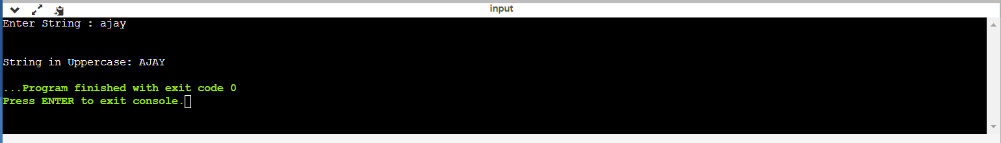**Output:-**

1. **Write a program to defines a function to add first n numbers.**

**Code:-**

**#include <stdio.h>**

**int main()**

**{**

**int i,num,sum=0;**

**printf("Enter an integer number \n");**

**scanf ("%d",&num);**

**for (i=1;i<=num;i++)**

**{**

**sum=sum+i;**

**}**

**printf ("Sum of first %d natural numbers = %d\n",num,sum);**

**return 0;**

**}**

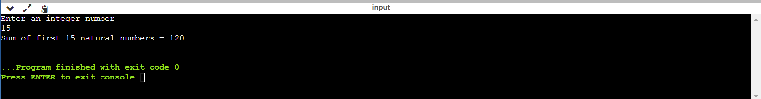**Output:-**

1. **Write a function in the program to return 1 if number is prime otherwise return 0.**

**Code:-**

**#include <stdio.h>**

**int prime(int);**

**int main()**

**{**

**int n,p;**

**printf("Enter a number : ");**

**scanf("%d",&n);**

**p=prime(n);**

**if(p==1)**

**{**

**printf("%d is prime\n",n);**

**}**

**else**

**{**

**printf("%d is not prime\n",n);**

**}**

**return 0;**

**}**

**int prime(int n)**

**{**

**int i;**

**for(i=2;i<n;i++)**

**{**

**if(n%i==0)**

**{**

**return 0;**

**}**

**}**

**return 1;**

**}**

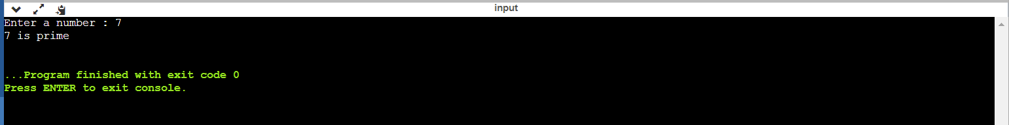**Output:-**

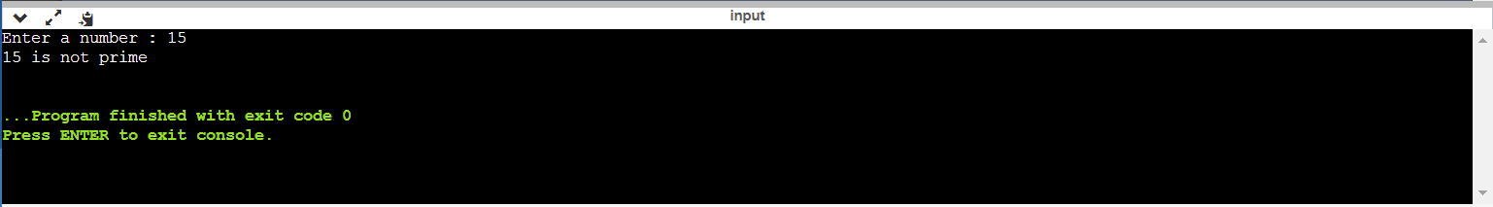

**Practical No.:-9**

1. **Write a program to find factorial of a number using recursion.**

**Code:-**

**#include <stdio.h>**

**int factorial(int);**

**int main()**

**{**

**int num;**

**int result;**

**printf("Enter a number to find it's Factorial: ");**

**scanf("%d",&num);**

**if (num<0)**

**{**

**printf("Factorial of negative number not possible\n");**

**}**

**else**

**{**

**result=factorial(num);**

**printf("The Factorial of %d is %d.\n",num,result);**

**}**

**return 0;**

**}**

**int factorial(int num)**

**{**

**if (num==0 || num==1)**

**{**

**return 1;**

**}**

**else**

**{**

**return(num*factorial(num-1));**

**}**

**}**

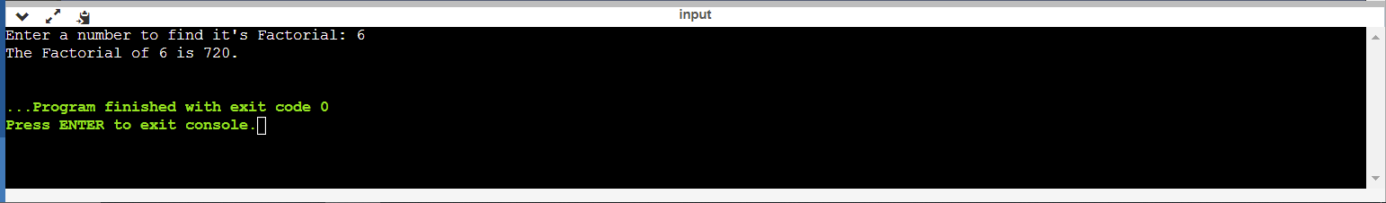**Output:-**

1. **Define a structure type struct personal that would contain person name, date of joining and salary using this structure to read this information of 5 people and print the same on screen.**

**Code:-**

**#include <stdio.h>**

**struct person**

**{**

**char name[20];**

**char doj[10];**

**float salary;**

**}**

**p[5];**

**int main(void)**

**{**

**int i=0;**

**for(i=0;i<5;i++)**

**{**

**printf("\nEnter Person Name : ");**

**scanf("%s",p[i].name);**

**printf("Enter Person Date of Joining (dd-mm-yyyy) : ");**

**scanf("%s",p[i].doj);**

**printf("Enter Person Salary : ");**

**scanf("%f",&p[i].salary);**

**}**

**for(i=0;i<5;i++)**

**{**

**printf("\n Person %d Detail",i+1);**

**printf("\n Name = %s",p[i].name);**

**printf("\n DOJ = %s",p[i].doj);**

**printf("\n Salary = %.2f",p[i].salary);**

**}**

**return 0;**

**}**

**Output:-**

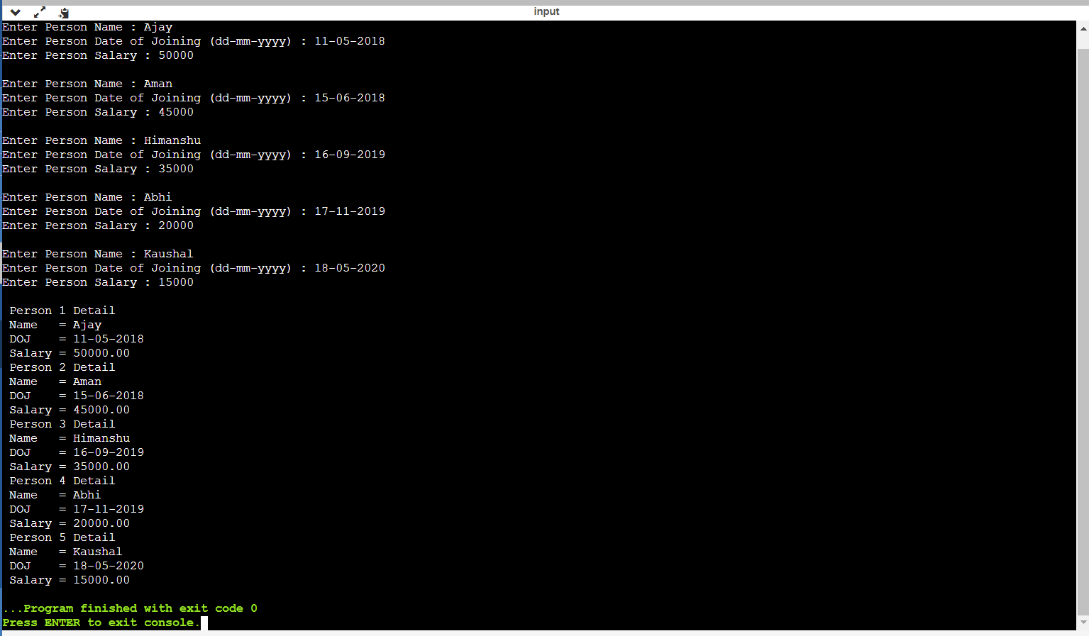

1. **Define a structure called cricket that will describe the following information:**

**Player name**

**Team name**

**Batting average**

**Using cricket, declare an array player with 50 elements and write a C program to read the information about all the 50 players and print team wise list containing names of players with their batting average.**

**Code:-**

**#include <stdio.h>**

**#include <string.h>**

**struct cricket**

**{**

**char player_name[20];**

**char team_name[20];**

**float batting_avg;**

**}**

**p[50],t;**

**int main(void)**

**{**

**int i=0,j=0,n=50;**

**for(i=0;i<n;i++)**

**{**

**printf("\n Enter Player Name : ");**

**scanf("%s",p[i].player_name);**

**printf("\n Enter Team Name : ");**

**scanf("%s",p[i].team_name);**

**printf("\n Enter Batting Average : ");**

**scanf("%f",&p[i].batting_avg);**

**}**

**for(i=0;i<n-1;i++)**

**{**

**for(j=i;j<n;j++)**

**{**

**if(strcmp(p[i].team_name,p[j].team_name)>0)**

**{**

**t=p[i];**

**p[i]=p[j];**

**p[j]=t;**

**}**

**}**

**}**

**j=0;**

**for(i=0;i<n;i++)**

**{**

**if(strcmp(p[i].team_name,p[j].team_name)!=0 || i==0)**

**{**

**printf("\n Team Name: %s",p[i].team_name);**

**j=i;**

**}**

**printf("\n Player Name = %s",p[i].player_name);**

**printf("\n Batting Average = %f",p[i].batting_avg);**

**}**

**return 0;**

**}**

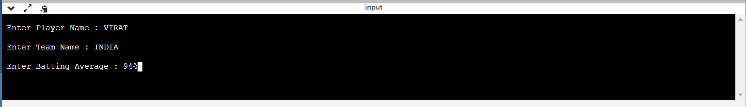**Output:-**

**Practical No.:-10**

1. **Write a C program to swap the two values using pointers.**

**Code:-**

**#include <stdio.h>**

**void swap(int *,int *);**

**int main(void)**

**{**

**int i=15,j=20;**

**printf("\n Before Swapping i = %d j = %d",i,j);**

**swap(&i,&j);**

**printf("\n After Swapping i = %d j = %d",i,j);**

**return 0;**

**}**

**void swap(int *a,int *b)**

**{**

**\*a=*a + *b;**

**\*b=*a - *b;**

**\*a=*a - *b;**

**}**

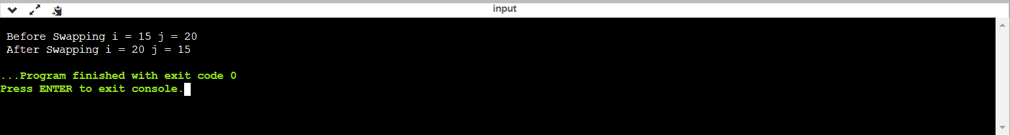**Output:-**

1. **Write a program for sorting using pointer.**

**Code:-**

**#include <stdio.h>**

**int main(void)**

**{**

**int a[10]={2,10,6,7,8,9,5,3,4,1};**

**int *p,i=0,j=0;**

**p=&a[0];**

**for(i=0;i<9;i++)**

**{**

**for(j=i+1;j<10;j++)**

**{**

**if(*(p+i) > *(p+j))**

**{**

**\*(p+i) = *(p+i) + *(p+j);**

**\*(p+j) = *(p+i) - *(p+j);**

**\*(p+i) = *(p+i) - *(p+j);**

**}**

**}**

**}**

**printf("\n Sorted Values : ");**

**for(i=0;i<10;i++)**

**{**

**printf("%d ",*(p+i));**

**}**

**return 0;**

**}**

**Output:-**



1. **A file named data contains series the integer numbers. Write a C program to read all numbers from file and then write all odd numbers into file named “even”. Display all the contents of these file on screen.**

**Code:-**

**#include<stdio.h>**

**int main()**

**{**

**FILE *f1,*f2,*f3;**

**int number,i, n=10;**

**printf("Contents of DATA file\n\n");**

**f1 = fopen("DATA","w");**

**for(i=0;i<n;i++)**

**{**

**scanf("%d",&number);**

**if(number==-1)**

**{**

**break;**

**}**

**putw(number,f1);**

**}**

**fclose(f1);**

**f1 = fopen("DATA","r");**

**f2 = fopen("ODD","w");**

**f3 = fopen("EVEN","w");**

**while((number = getw(f1)) != EOF)**

**{**

**if(number%2==0)**

**{**

**putw(number,f3);**

**}**

**else**

**{**

**putw(number,f2);**

**}**

**}**

**fclose(f1);**

**fclose(f2);**

**fclose(f3);**

**f2 = fopen("ODD","r");**

**f3 = fopen("EVEN","r");**

**printf("\n\n Contents of ODD file \n\n");**

**while((number = getw(f2)) != EOF)**

**{**

**printf("%d ",number);**

**}**

**printf("\n\nContents of EVEN file \n\n");**

**while((number = getw(f3)) != EOF)**

**{**

**printf("%d ",number);**

**}**

**fclose(f2);**

**fclose(f3);**

**return 0;**

**}**

**Output:-**

